**Experiment 5**

**Aim:To familiarize with aggregate functions**

**Questions**

1. List total loan

SELECT SUM(AMOUNT) FROM BORROW;

1. List tota ldeposit
2. List total loan taken from KAROLBAGH branch

SELECT MAX(AMOUNT) FROM BORROW WHERE BNAME

=&#39;KAROLBAGH&#39;

1. List total deposit of customers having account date later than 1-Jan-96 5.List total deposit of customers living in city NAGPUR
2. List maximum deposit of customer living in Bombay
3. List total deposit of customer having branch in BOMBAY
4. Count total number of branch cities 9.Count total number of customers cities
5. Give branch names and branch wise deposit
6. Give city wise name and branch wise deposit
7. Give the branch wise loan of customer living in NAGPUR
8. Count total number of customers
9. Count total number of depositors branch wise 15.Count total number of depositors branch wise 16.Give maximum loan from branch VRCE

17.Give the number of customers who are depositors as well as borrowers

**Answers**

1. List total loan

SELECT SUM(AMOUNT) FROM BORROW;

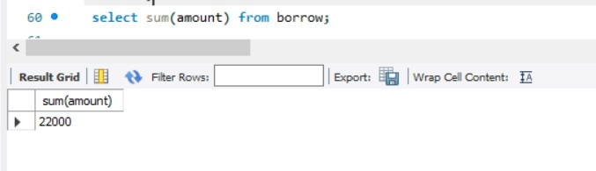

1. List total deposit

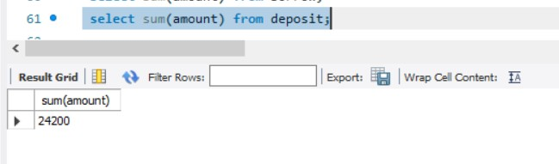

1. List total loan taken from KAROLBAGH branch

SELECT MAX(AMOUNT) FROM BORROW WHERE BNAME ='KAROLBAGH';

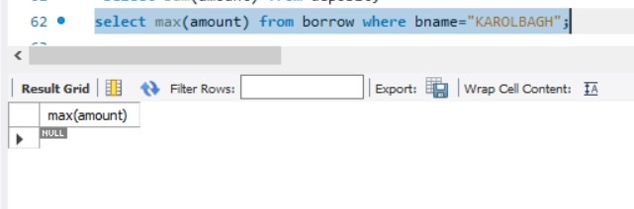

1. List total deposit of customers having account date later than 1-Jan-96

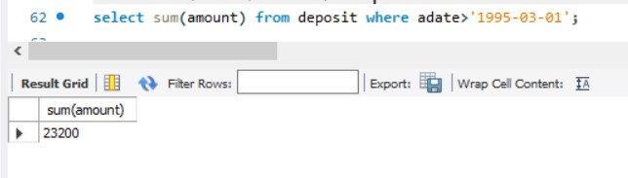

1. List total deposit of customers living in city NAGPUR

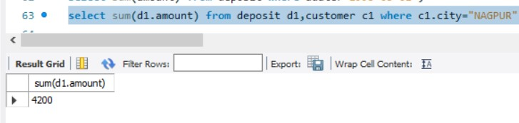

1. List maximum deposit of customer living in Bombay

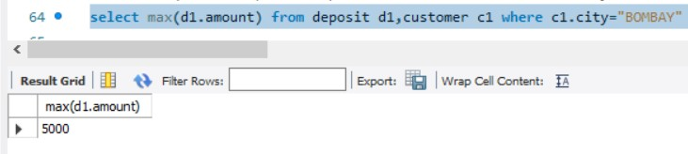

1. List total deposit of customer having branch in BOMBAY

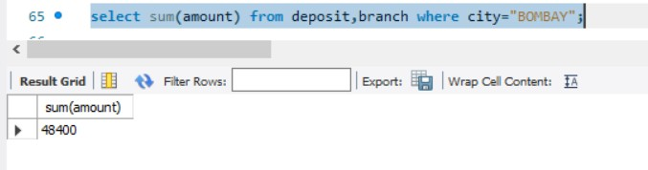

1. Count total number of branch cities

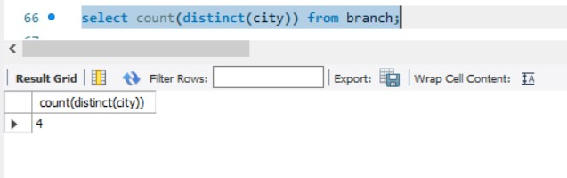

1. Count total number of customers cities

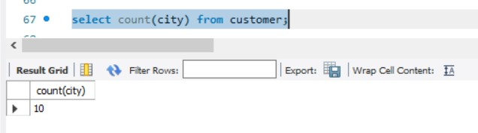

1. Give branch names and branch wise deposit

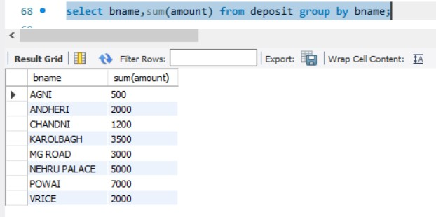

1. Give city wise name and branch wise deposit

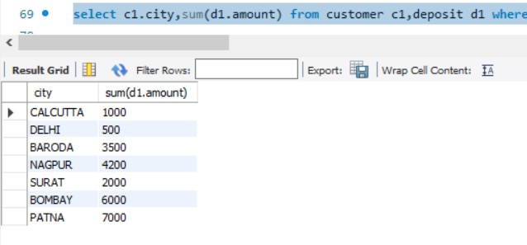

1. Give the branch wise loan of customer living in NAGPUR

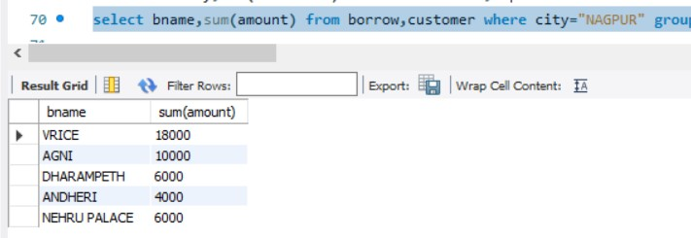

1. Count total number of customers

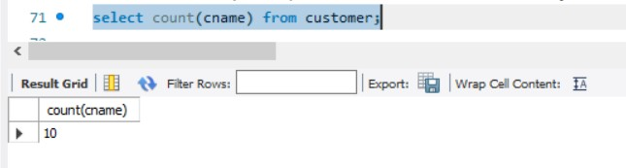

1. Count total number of depositors branch wise

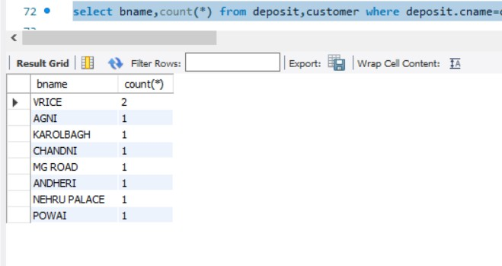

1. Count total number of depositors branch wise



1. Give maximum loan from branch VRCE

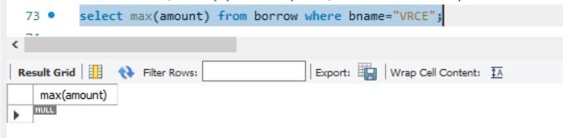

1. Give the number of customers who are depositors as well as borrowers